Bradford and Chicago: Community Co-Creation Exchange
20th November 2019
10am-1pm
Stony Island Arts Bank

Context:
In November 2019, a small group of us based in Bradford in the UK – museum practitioners and researchers – came to Chicago with the aim of exploring the leading-edge community engagement work, participatory and co-creative practice.

The Bradford delegation have been working together on a project called Bradford’s National Museum, which has been using action research approaches to understand better how the National Science and Media Museum as a national cultural institution might develop a strong local role and to explore ways for the museum to become more open, engaged and collaborative. Chicago and Bradford have many differences. However, what they share is a need to proactively address racism, develop cross-community conversations and deal with urban regeneration in ways which engage existing communities, resist gentrification, and build community wealth. Both cities also show the potential of establishing powerful roles for museums and cultural organisations in these contexts.

We were motivated by understanding both the histories of community organising and community participation in Chicago as well as the work that is happening in the city now. In collaboration with Elory Rozner (Uncommon Classrooms), we contacted diverse organisations that have demonstrated a commitment to innovative community convening through the arts and sciences. We then invited an incredible group of people to join us for a workshop. What follows is a write up of the workshop and the key ideas that emerged that we will be taking back into our action research in Bradford.

Workshop Participants
Julia Ankenbrand, University of Leeds and British Museum
Helen Graham, University of Leeds
Nabeelah Hafeez, Bradford Stories Festival and National Literacy Trust
Regin Igloria, North Branch Projects
Guenievre Jacobucci, National Science and Media Museum
Manny Juarez, Museum of Science and Industry
Sarah Ledjmi, National Science and Media Museum
Nenette Luarca-Shoaf, Art Institute of Chicago
Faheem Majeed, Floating Museum
Ira Murfin, Chicago Humanities Festival
Erik Peterson, Smart Museum of Art (University of Chicago)
Jo Quinton-Tulloch, National Science and Media Museum
Elory Rozner, Uncommon Classrooms
Lydia Ross, Department of Cultural Affairs and Special Events
Jennifer Schwarz Ballard, Chicago Botanic Garden
Vanessa Sanchez, Yollocalli/NMMA
Jennifer Scott, Jane Addams Hull-House Museum
Nell Taylor, Read/Write Library
Rich Warbuton, Theatre in the Mill and University of Bradford
Lynn Wray, University of Leeds
Julie Yost, Rebuild Foundation

All photographs: Credit Erik Peterson

Opening the workshop
The workshop was facilitated by Elory Rozner and Helen Graham. Before the workshop, everyone who took part sent through three words that are important to them in their practice. We welcomed everyone to the workshop by asking them to share their name, their organisational and their three words.

The idea was that these words could be used throughout the workshop as tokens of exchange, honouring the title of the workshop.

You can see the cards people created with their words in an online album and read the words and the post it notes produced through the small group discussions in Appendix 1. Taken together the words read as a lexicon for co-creation.

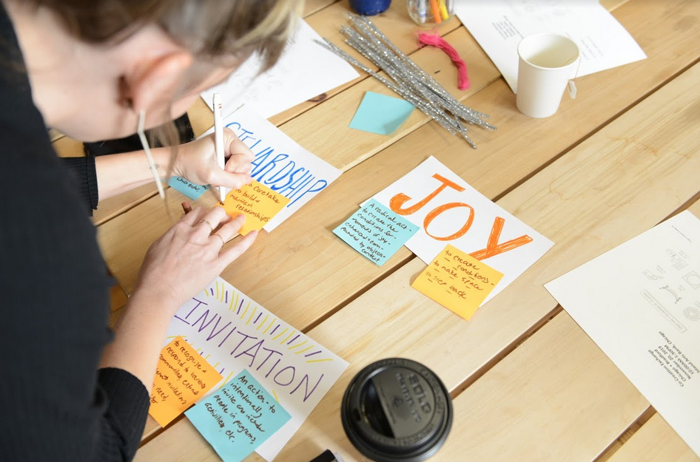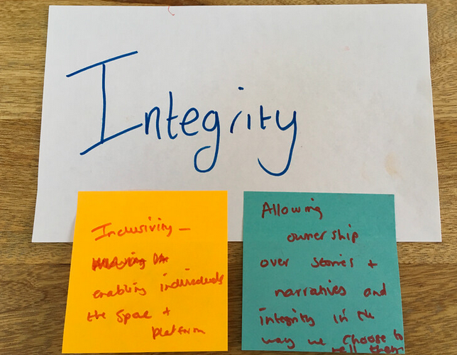

SMALL GROUP INVESTIGATION 1: Convergence: similar words / exploring meaning

In the first section of the workshop, we asked people to meet up with two other people who had identified similar words.

We asked people to: Share your words. What do your words mean to you?
We asked people to: Following the conversation, use one post-it note to annotate the word with additional words to give more depth and context.

The annotations of words that took place during the first discussion reveal rich thinking beneath each word. Each word being tethered – often in quite different ways – to other ideas, indicating specific traditions of thinking or activism.

In this way, words that might have been expected – such as ‘access’ and ‘community’ – are given new leases of life. Access is linked to ‘legibility’ and ‘comfort’. ‘Community’ is contextualised as ‘location, culture, interests’. ‘Community ownership’ is linked to ‘self-determination’.

Collaboration is:

Commitment.
Shared goals.
Mutual respect.
Recognizing / appreciating / celebrating difference.
Filling each other’s gaps.
Multiple levels, individual, organizational, cross-organization.

Words that might have been less expected – when added to this lexicon – open up windows into specific people’s thinking. Verbs abound: to ‘Arc’, to ‘Build’, to ‘Make’, to ‘Provoke’, to ‘Value’. In the post-it notes that drew out the thinking, a verbing unfolds that indicates the process-based and emergent thinking behind the choice of words. ‘Make’ is: ‘What the community brings; The humanity: Human capability’. ‘Build’ is:

Build relationships,
Build public(s)
Build agency
And literally ‘building projects’ with wood, paint, cardboard, clay, like an artist does!

Yet the words also indicate that it is not what you do but how it feels or the character with which something is done. ‘Compassion’ is ‘Compassion and understanding; Kindness and openness; Creating safe spaces’. ‘Joy’ was a word brought by four different people. ‘Joy’ is:

A radical act to create the conditions for moments of joy, enhanced and compounded by objects and context.

Or there was ‘Sly’ as a way in which the work is done:

Be able to keep people on their toes, surprise audiences, utilize humour, keep the institution flexible.

SMALL GROUP INVESTIGATION 2: Divergence: different words / identify capacity for action

In the second section of the workshop, we asked people to meet up with two other people who had identified different kinds of words.

We asked people to: Share your words. Notice their differences. What do your words enable you to do? What capacities do they have?
We asked people to: Annotate the words with a second post-it note following the discussion.

The annotation of the words in response to the action and capacity questions indicate the trajectories and imaginative spaces in which people are working. Reading the second column of the lexicon, the words morph into active tools for work and for change. Most of the words – in terms of the capacities noted – feel like they make possible maintenance work. They indicate the everyday hard work needed to keep spaces open to different people, open to new ideas and not to close down and return to type. ‘Context’ ‘Enables us to build relationships based on partners and audience goals and needs’. ‘Crossover’ allows for ‘Indoors – out Moving/ removing doors open; Moving through them’. Having ‘People’ as a key word allows you to ‘keep processes human’. ‘Community Ownership’ ‘Enables us to constantly critique our own institution and iterate’. ‘Build’ both means ‘Use your hands for art making’ and ‘Make, sustain, relationships, across institutions’. Think about ‘Youth’ is a concrete prompt to:

Give agency.
Give space.
Give money.
Create opportunities.

Other elaborations of the capacities of words felt more like possibility thinking, a sort of utopian strain infusing everyday work. ‘Adaptability’ ‘Might lead back to listening’. ‘Agency’ is ‘the power you have to shape your world’ and allows you to ‘Think politically.
Open up critical thinking.’ ‘Courage’ is to:

Experiment.
Take changes.
Have a thick skin.
Talk yourself into things.

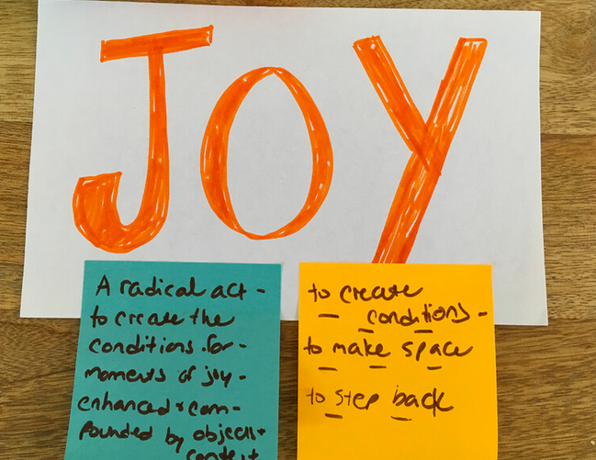

‘Joy’ is a way to ‘Keep the curiosity alive’. ‘Relations’ is:

Thinking systemically.
Working without the idea of inside and outside.
Being fluid.
Paying attention to my impact.
Reacting.
Dancing.

CO-CREATION: what do different words help us to do differently?

We then came together to see all of our words in relationship to each other. We did this through making a map and then using the map to draw out key ideas.

Making the map

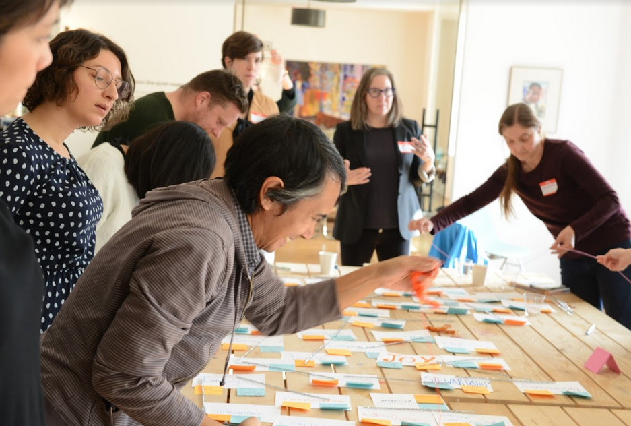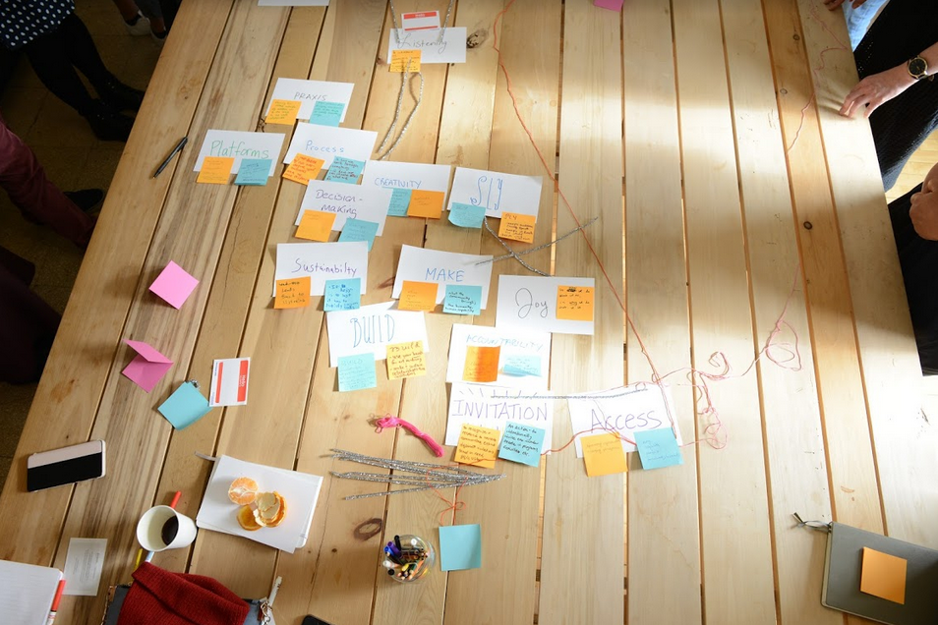

We asked people to: Work together to create a word map. What connects the words by the capacities for action they have? This activity was fast. People moved things, and we made it clear that there is no need to be precious; we were living the different connections through sorting them out. The map-making was not consensus-orientated, there were lots of small-scale negotiations going. It was left as good enough when the time ran out.

Discussion

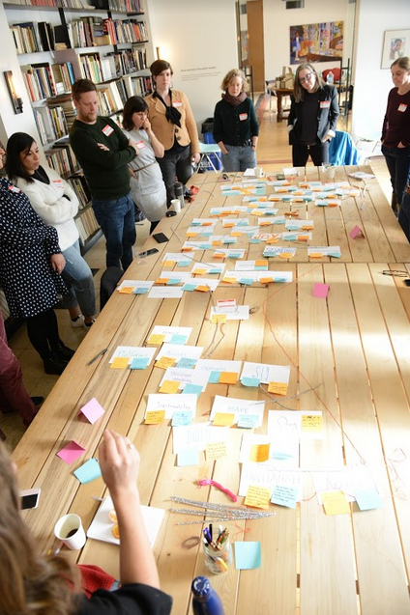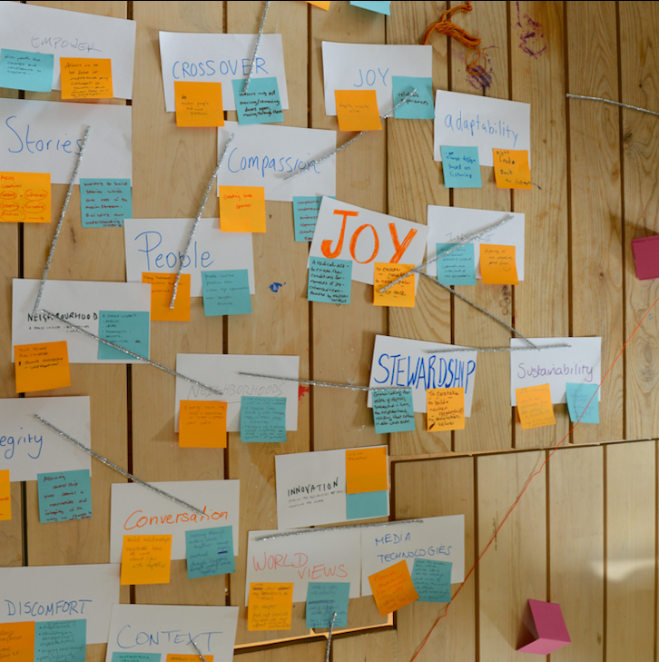

Word map
There were four major ways in which people made sense of the map of words. Each of the four ways suggested different images of cyclical returns to core principles, of a heartbeat and a pulse, of chance and of a constant reconfiguring of constellations of words, with each new constellation opening up new questions.

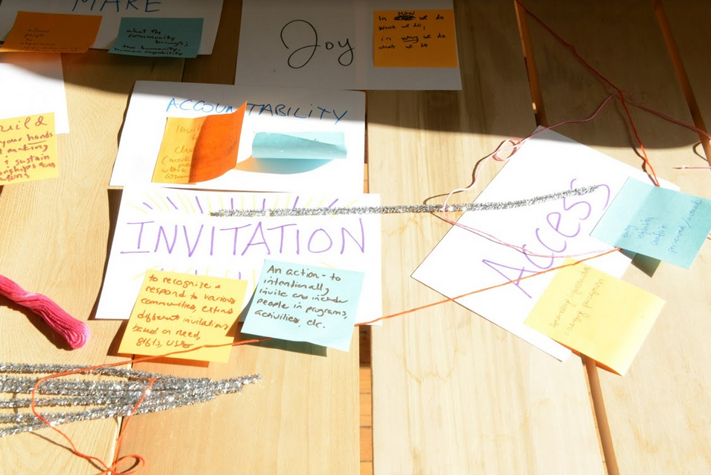

- A linear story or a cyclical story
Lydia: I would say it seems like we're moving in circles or cycles that repeat themselves. What I noticed if I'm reading it right, is that if there is a linear narrativeish, it starts from the top down. That the words repeat themselves in various stages, because listening at the very beginning isn't enough.
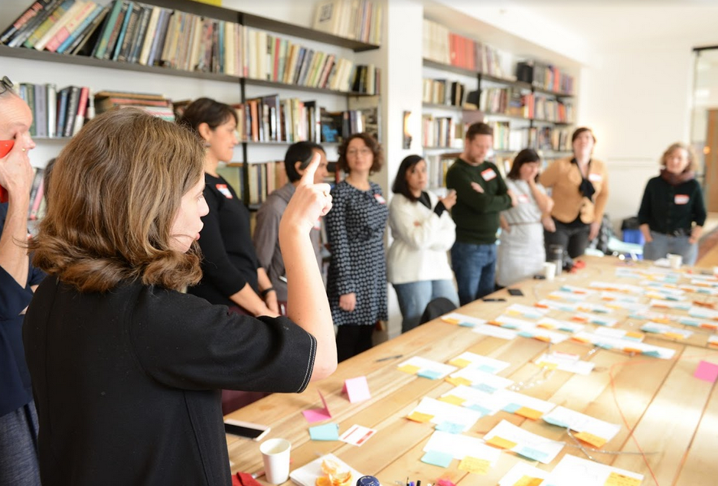

- A tree
Nenette: So this looks like a tree to me with roots in the ‘Invitation’ and ‘Access’ and it kind of blossoms up with these different branches and that at the top of the tree, maybe it's the last to grow. The oldest or the hardest to reach is ‘Agency’, ‘Ownership’ and ‘Self-determination’.

- An anatomy
Jennifer Scott: Community, however you define it, is not cursory, but is the energy and the drive and the decision-making at the core of everything. So in looking at this, I was thinking of it more, definitely not linearly, but like an anatomy (although I don't know if it's a human or sci fi character!). That part [points to map and the ‘Agency’, ‘Self-determination’ and ‘Ownership’ cluster], is like the heart or the pulse that's always there, pulsating, driving and energizing. Everything is in the heartbeat.

- A story of chance and new constellations
Erik: What if these words were all in little boats that you just put into a machine and then then 'joy' bumps into 'crossover' bumps into 'people' and then, how do you create, through that [chance] in that way? Just having a little daydream. […] But when you put ‘Sustainability’ next to ‘Stewardship’ and ‘Joy’, you're like, oh, what does it mean in that context or next to ‘decision-making’? I think that is what Nenette did. Or [when you put] Creativity with Decision-Making, that is not necessarily always what we're thinking about.

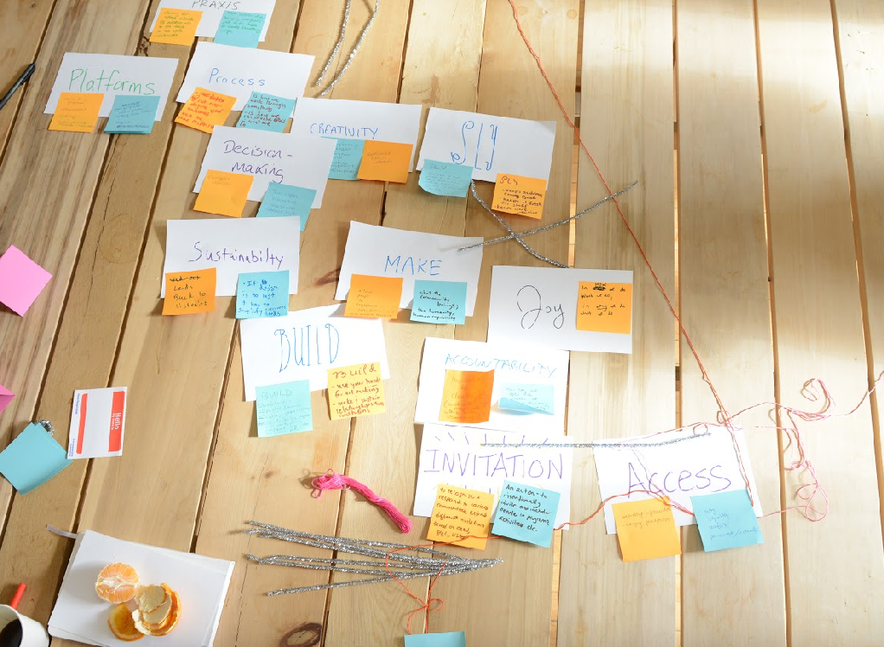

The discussion then moves on to exploring different ideas which are grouped here in themes.

Traditions: Grassroots activism and autonomous self-organization
Key idea: There are traditions in Chicago of grassroots community action and autonomous self-organisation that inform the work of many people involved in workshop.

Nell: Also, as a Chicago native, I think there is a lot that comes out of being steeped in the grassroots institutions that actually sustain our neighbourhoods. Because once you get outside of downtown, there is so much that's just been built by the community that we've all benefited from. And I know that informed the way that I think about that work, too.

The problem with the term ‘inclusion’
Key idea: The word ‘inclusion’ sets up a politics of invitation rather than community ownership – and sometimes communities need to be able to self-organise to make change.

Nell: But from our perspective as an organization, everything that we do is rooted in community ownership. And it's a constant way for us to self-critique and make sure that what we're doing is not just inviting people to come to us and not just saying, ‘hey, you get to be included in what we do’, but really recognizing the authority and expertise that communities already have and elevating that and raising its visibility and making that the defining factor in our work.

Jennifer Scott: And the reality is sometimes you need exclusion to make change, to support agency. [Inclusion is] not the answer all the time.

Elevation: spotlight or enhancement?
Key idea: The word ‘elevation’ kept recurring – it might mean mixing the local in the way a Michelin-starred restaurant might with ingredients or it might mean raising the local as a north star guide.

Erik: Every Michelin star restaurant is like taking the local food and elevating it. It's like we have dill, we have things that grow [locally]. And I think what you guys are talking about, I could be wrong, but like the community has all this intrinsic knowledge, has its creativity, has its deliciousness. And it is how do you bring it, how do you use your resources to make it…

Nell: That is actually not the way I was thinking about elevating. So not in terms of making it Michelin-ready and making it palatable (to continue to use the food analogy), but in terms of really making it visible. And not just making it visible, in terms of like, ‘hey, here it is we gave it to you’ but actually lifting it up, like literally elevating it and saying, this is what our guide needs to be.

Faheem: I like spotlighting. Not moving something from one place to the other, but a way of kind of highlighting it so that your exchange actually benefits the thing that's already there. It's not about changing that thing, it is about giving it access to a set of networks that you may have access to. But also that exchange, I benefit from that too, because now I have access to that network and those networks are just as valuable as mine.

Ecology: Network or Embedment
Key idea: The ecology of organisations matters, this can be like a network but it can also work as an form of embedding that opens up new possibilities within large organisations.

Vanessa: I am from Chicago, born and raised. For one reason. I feel like that's also a huge part of why I have so many connections is because I have a strong history. My family has a strong history here. And the institution that I am with has a strong history here. And so I continue to branch out from that.

Lydia: So I think working on a really micro level, [and] remembering to look. When we're talking about recognizing the expertise that's already in a community, even within your own micro community, who are your allies and who is a foe who maybe you haven't had the right conversation with?

Erik: Lydia's group, it is the City of Chicago, which is gigantic, but it's also a small group of real people who are doing great things and have a great amount of agency to do a lot of things. And you guys have had people like the Floating Museum embedded inside deep, but inside Chicago Cultural Center in a public way. And you've had like Aram Han Sifuentes doing her protest banner lending library embedded in the city but in a public free place. So it's like there's ways to have these little institutions that are sort of nimble and fast and doing things to the side of it, like to the side of, where you want to go and to see how it worked.

Acknowledging limitations; and acting as if there were no limitations
Key idea: Big and old organisations might have limitations and there is a real honesty to talking about them openly…this can lead to change but sometimes acting as if there are no limitations is a good tactic!

Faheem: There is also the reality of limitations. You're not going to change the museum because you're not. So you have to work so you can change it over time. But it took hundreds of years to get it to where it is. It's not going to change in one lifespan. I am talking about the big budget museums, but your role [is] to kind of push that in a certain direction, in my opinion. There was a time when I just got really frustrated that […] large museums were operating in the way they were. Why can't you see this thing? And I'd talk to individuals. Individuals would say ‘that's fucked up, you know, Yeah. We should do something’ and then it is like those conversations just kept repeating versus understanding the limitations that are placed by the gears and the machine [of large museums]. But there's ways to navigate that potentially. And if you just put that on the table when you're designing up a thing and you know that's coming and that also impacts your community partnerships. And each one of us has a different type of institution, [with] limitations within it. But [the limitations] have to be on the table with all our hopes and dreams.

Nell: I like the idea of putting the limitations on the table too. Whoever wrote ‘discomfort’, I just really feel that if you are putting those limitations on the table and saying this is what we know right now […]. Yeah. I just I just really feel like, if you're not putting those limitations on the table and saying ‘here's what we know right now to be limiting what we can do or affecting the way that we work together’. There's actually a lot of opportunity in acknowledging that, because if you know what's going on beneath the surface, if you look at the systems, that's how you actually figure out what things can be subverted and tweak to make things better.

Jennifer Schwarz Ballard: There is a difference between the work that we do in communities and what happened on site at the garden. […] And one of my goals is to try to better connect those two. Chicago Botanic Garden's up on the North Shore, [it is a] rich white community. [The aim] is to start challenging the conceptions of our current visitors a little bit more and really giving them opportunities to think about the space of the garden in different ways, through different eyes.

Jennifer Scott: It's very easy to talk yourself out of things. It's harder to talk yourself into things. […] But really nothing is going to change unless people experiment and take a chance. We were talking earlier in our smaller groups about just trying. […] A lot of times I find […] people just haven't tried something new. At the Museum we just have a philosophy: do it until people say no. And then, keep trying. It takes a kind of courage. […] I think that's when support networks and experience really come in handy for people who are also feeling afraid or hesitant and really want to try to make a difference. I try to source my strength from the communities we work with, and from other practitioners, thinkers and doers.

Nenette: Maybe those limitations aren't static either that they change and can be changed […] so as they evolve […] there are many different communities, some of whom are trying to change those limitations, not in order to [for a] large museum to try be a small museum, community museum, because it's not that, there are other people doing that better. But to make to re-shape […] the map of that ecosystem, even with its weight.

Cultures of Funding
Key idea: Collaboration is not just about being fun, it related to the cultures of funding and the cultures produced by funding.

Faheem: So a lot of us talk about the grassroots things but it comes out of survival [because of the need to attract funding].

Lydia: I think that's true also of larger organizations that are looking for funding, collaborations are really important to the Chicago philanthropic community. And so there is sort of an underlying sort of imperative to do that collaborative work, whether you're a small organization or a big one.

Ending the workshop
We ended the workshop with final thoughts and a final round of words – this time related our thoughts and feelings after the conversations. The words were:

- Human
- Thank you
- Sly
- Chance
- Good Community
- Enlightened
- Rehearsal
- Inspired
- Reflection
- Richness
- Open
- Resolve
- Invitation
- Reflective
- Grateful
- Position
- Bubbling
- Let Go
- Humility
- Motivated
- Take Risk
- Reciprocity

Questions to take away:

From this discussion, the Bradford’s National Museum project will take away the following questions to active work with:

- What words are we using – and what capacities for action and change do they have? How might we mix words up to create new possibilities?

- What traditions of place can be drawn on in our work?

- What are the different ways in which might elevation work – can we experiment with this?

- How can we cultivate both an ecology and also a network (as they might not be exactly the same thing)?

- How to be open about limitations and use that openness to also act as if there are no limitations?

